Postdoctoral Scholar Program Online Application Guide
Applicant

1. Login
Applicants should register a user account to access Academic Service and Management System (https://asms.sinica.edu.tw) to start the application. AS colleagues may use their SSO accounts to log in.
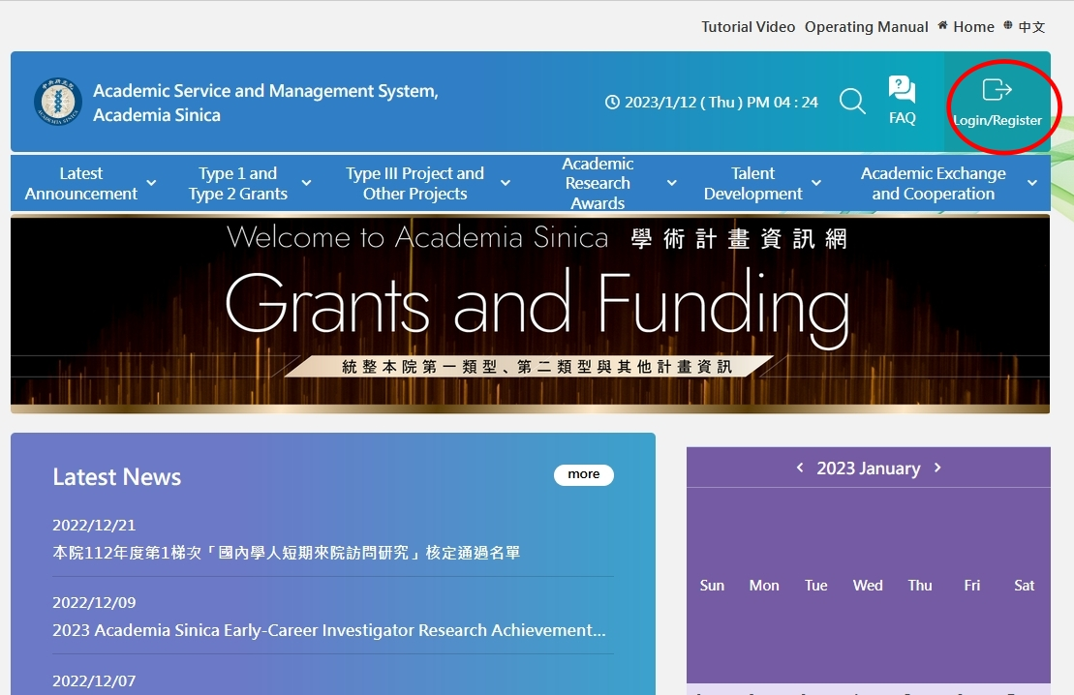

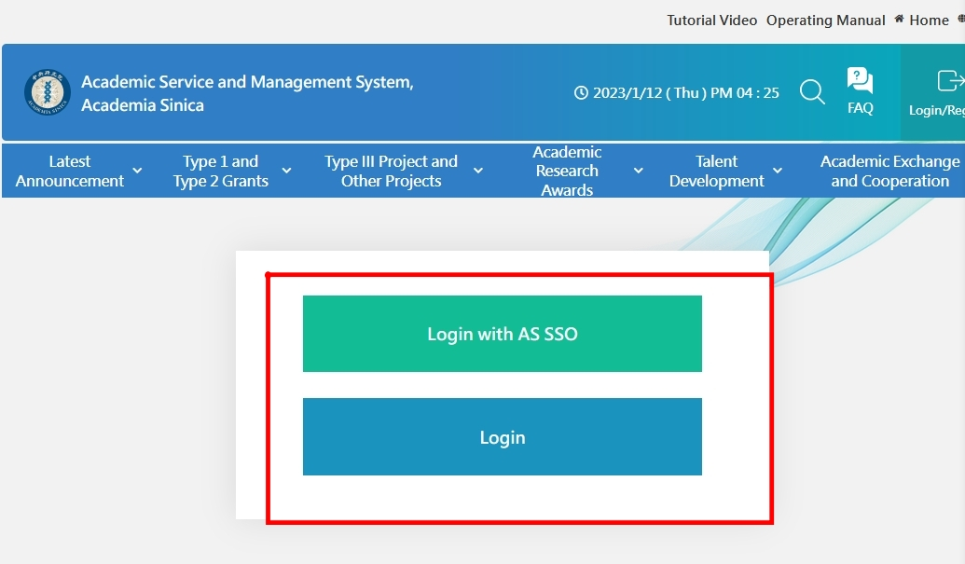
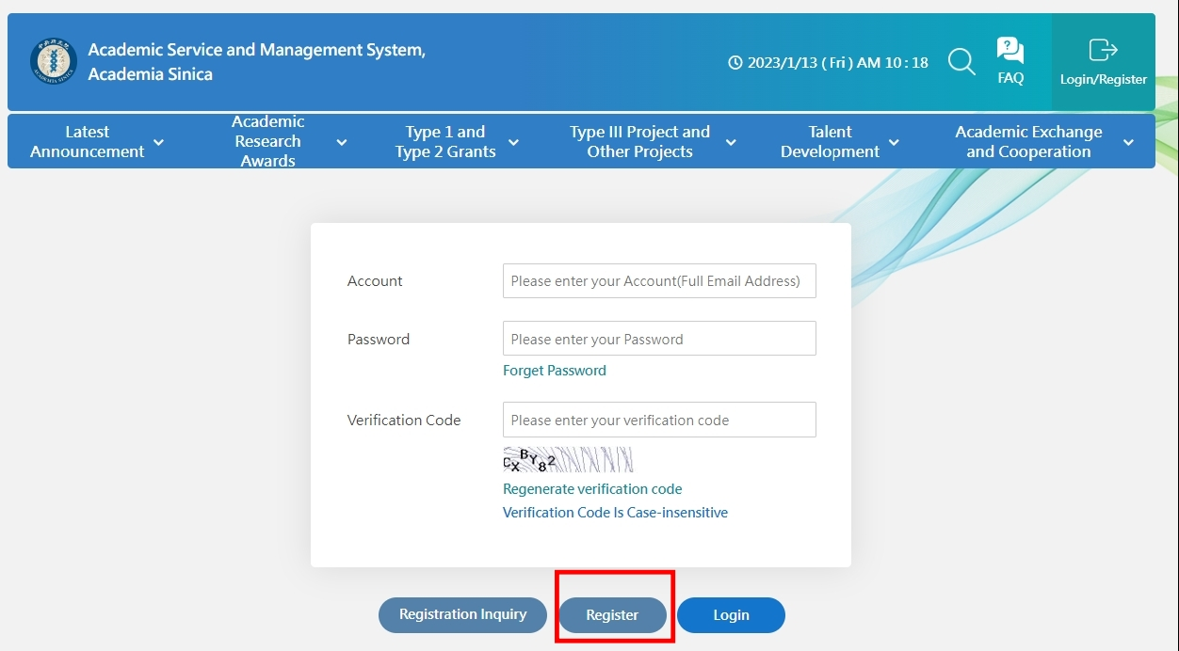

2. Switch Role
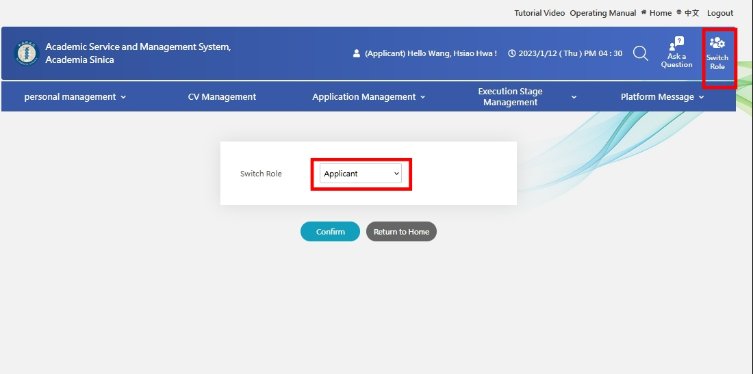
3. Update CV
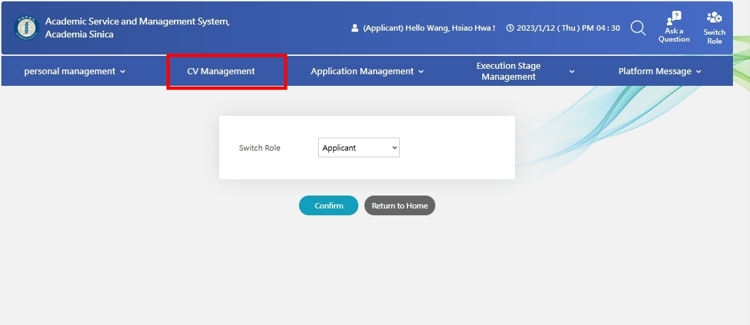

4. Select the application item
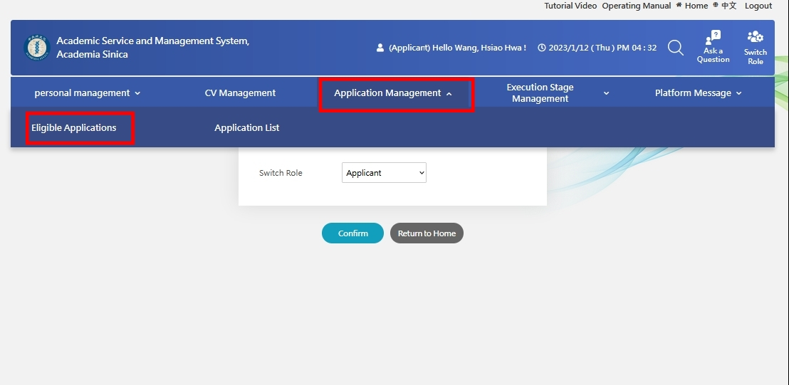
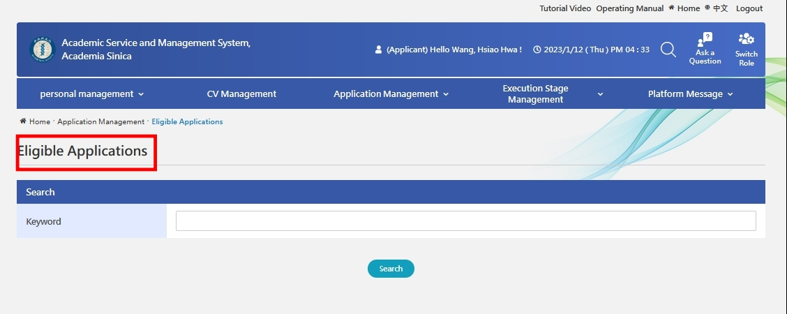
Academia Sinica Postdoctoral Scholar Program (Mathematics and Physical Sciences)-2024 1st Round Application
Academia Sinica Postdoctoral Scholar Program (Life Science)-2024 1st Round Application
Academia Sinica Postdoctoral Scholar Program (Humanities and Social Sciences)-2024 1st Round Application

5. Complete the required documents and submit the application to your sponsoring mentor
(1) Basic Information
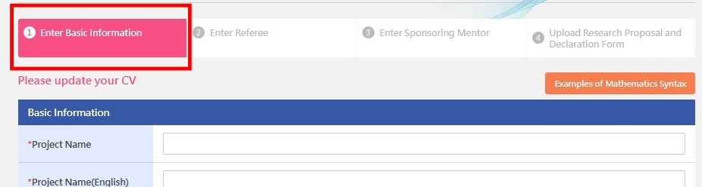

(2) 2-3 referees
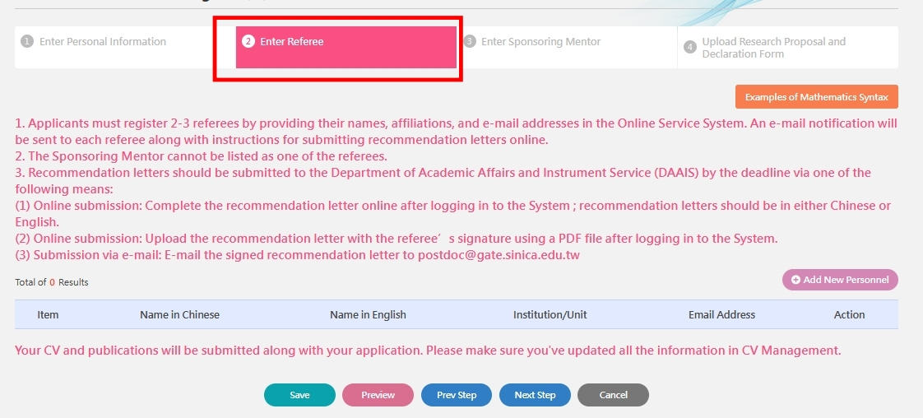
(3) Sponsoring Mentor
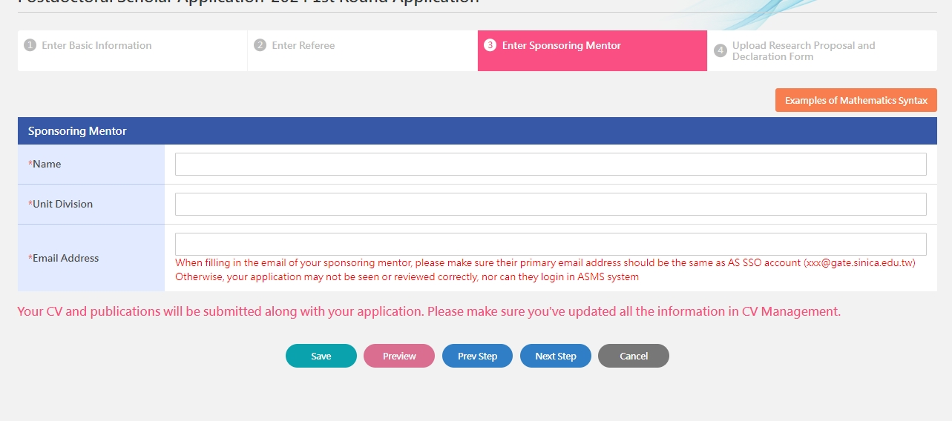
(4) Research Proposal
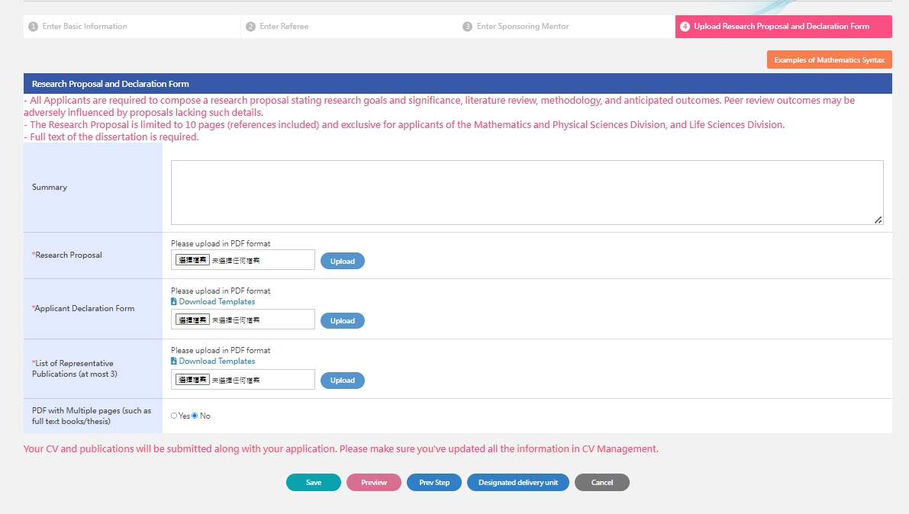
Sponsoring Mentor

1. Login Academic Service and Management System (https://asms.sinica.edu.tw)

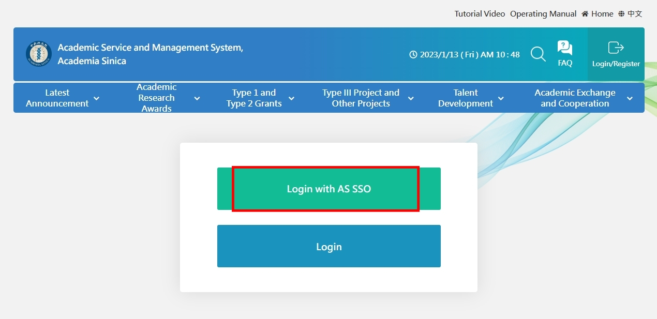

2. Switch Role
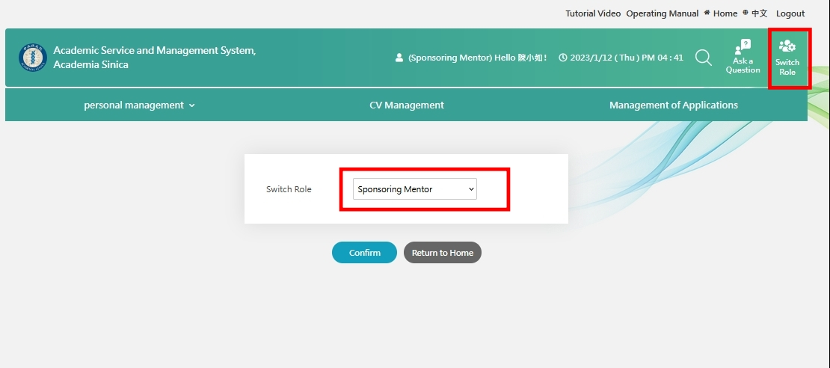

3. Submit the required documents
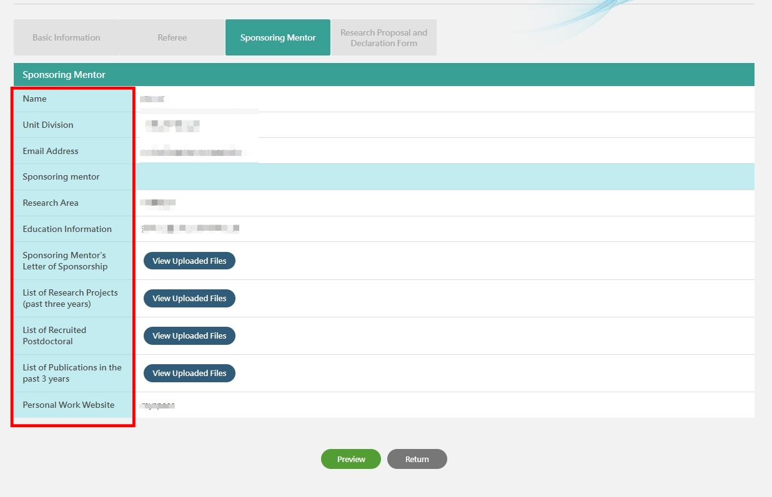

Referee

1. Login

Referees should register a user account to access Academic Service and Management System (https://asms.sinica.edu.tw). AS colleagues may use their SSO accounts to login.

2. Switch Role
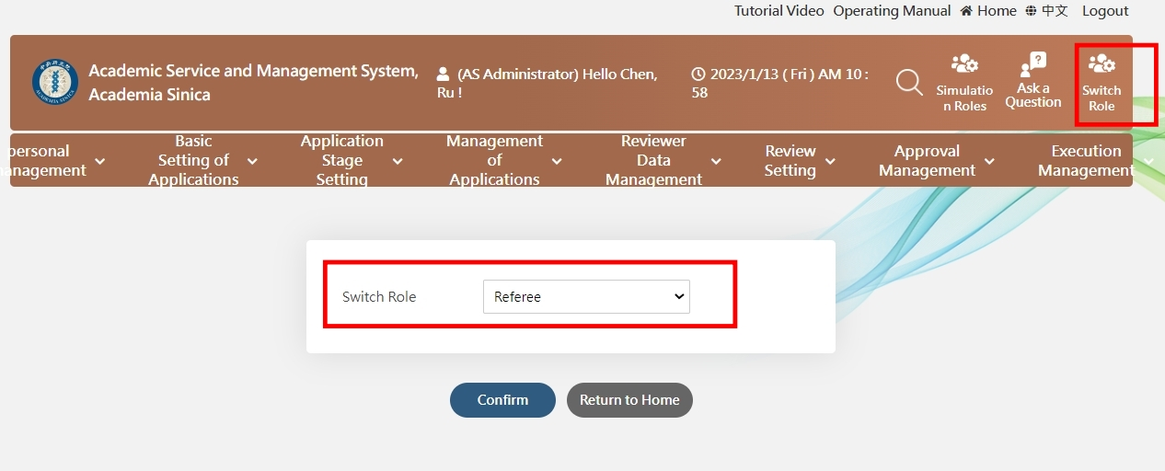

3. Complete the recommendation letter online or upload the letter with the referee’s signature in PDF format
